

**WEBSITE DEVELOPMENT**

### A Project Report

#### in partial fulfillment for the award of the degree of

**Bachelor of Technology**

### IN

### Computer Science and Engineering

### SCHOOL OF COMPUTING SCIENCE AND ENGINEERING

#### Under the Supervision of Submitted by

### **Ms. Puneet Kaur, Professor AMARPREET SINGH (20BCS4438)**

**JULY 2022 AYUSH SURYAWANSHI (20BCS4424)**

**ADITYA ARORA (20BCS3758)**

**ONKAR DHISHAN (20BCS4425)**

**SAGAR GROVER (20BCS3802)**



**BONAFIDE CERTIFICATE**

Certified that this project report **“WEBSITE DEVELOPMENT”** is the bonafide work of **“AMARPREET SINGH (20BCS4438),** **AYUSH SURYAVANSHI (20BCS4424), ADITYA ARORA (20BCS3758), ONKAR DHISHAN (20BCS4425) , SAGAR GROVER (20BCS3802) ”** who carried out the project work under my supervision.

### SIGNATURE OF HEAD SIGNATURE OF SUPERVISOR

##### Mrs. Puneet Kaur

##### Professor

##### Computer Science & Engineering Computer Science & Engineering

##### 

### ACKNOWLEDGEMENT

We would like to express our deep gratitude to our project **Ms. Puneet Kaur** Assistant Professor, Department of Computer Science and Engineering, Chandigarh University for her guidance with unsurpassed knowledge and immense encouragement. We are grateful to Dr. Aman Kaushik, Head of the Department, Computer Science and Engineering, for providing us with the required facilities for the completion of the project work.

We thank all **teaching faculty** of Department of CSE, whose suggestions during reviews helped us in accomplishment of our project. We would like to thank **Mr.Bhagwati Sharan** of the Department of CSE, CU for providing great assistance in accomplishment of our project.

We would like to thank our parents, friends, and classmates for their encouragement throughout our project period. At last but not the least, we thank everyone for supporting us directly or indirectly in completing this project successfully.

**PROJECT STUDENTS**

Amarpreet Singh - 20BCS4438

Ayush Suryavanshi - 20BCS4424

Aditya Arora - 20BCS3758

Onkar Dhishan - 20BCS4425

Sagar Grover - 20BCS3802

**TABLE OF CONTENTS**

* **List of Figures**

* Fig 3.1 Context Level Diagram
* Fig 3.2 First Level DFD
* Fig 3.3 Second Level DFD
* Fig 3.4 Use Case Diagram
* Fig 3.5 Flow Chart for Adding New Customer
* Fig 3.6 Flow Chart for Adding New Product
* Fig 3.7 DFD For Customer Registration
* Fig 3.8 DFD For Customer Login
* Fig 3.9 DFD For Adding Item to Cart
* Fig 3.10 DFD For Customer Payment Method
* Fig 6.1 Product Code
* Fig 6.2 System Files
* Fig 6.3 Product List
* Fig 6.4 Cart Page View
* Fig 6.5 Index Code
* Fig 6.6 Sign UP / Login Page
* Fig 6.7 Check out page
* Fig 6.8 Home Page
* Fig 6.9 Admin Page
* Fig 7.1 Result

### CHAPTER NO. TITLE PAGE NO.

1. Abstract 6
2. Introduction 7
3. Literature Survey 11
4. Design and Flow Process 13
5. Software Requirement Specification  19
6. Related Work  20
7. Code And Website View 21
8. Result 30
9. Future Scope 31
10. Conclusion 32
11. Limitations 33
12. References 34

# ABSTRACT

The driving force of e-commerce is both technological innovation (under great pressure to innovate) and business orientation. This report provides guidelines for companies looking to enter e-commerce to develop an e-commerce strategy, or companies that already have an e-commerce presence to revamp their existing strategy. E-commerce is now seen as a reality for many companies and is seen as a regular part of their business plans. At every stage of the supply chain, the direct benefits of reduced costs, efficiency and increased profitability are evident. E-business adoption is no longer a competitive advantage, it is a normal business process without which companies in the new economy cannot survive. Many dotcom companies were founded in 2000 and many companies entered e-commerce, but now it's a different story. More and more companies are failing, and investors are being wary of investing in internet ventures. I need more money than expected. Some of them, like everyone else, have had to jump on the bandwagon, not wanting to be left behind, and now that the bubble has burst, they are facing the consequences. It is intended to help you understand what you need to follow in order for your business to be successful if you have the right plans and a good strategy.

# INTRODUCTION

Electronic commerce (e-commerce) is a fairly new idea, and it is very common practice nowadays for businesses to conduct trade over the Internet. There are various advantages to e- commerce (e.g., lower cost, convenience). E-commerce can simply be defined as buying and selling merchandise or services online. Most successful businesses today have their own websites. Today, it is possible to conduct business nationally and globally with a click of a fingertip due to the worldwide use of the Internet. To be successful in the global marketplace, businesses need to develop culturally friendly e-commerce websites. When conducting business online, factors such as region and culture, web content accessibility, ease of use, secure authentication, payment, fraud detection, performance, trust, stability, technology, and convenience are vital to the businesses and consumers’ satisfaction and interest. This is a less focused research area and needs significant attention. commerce, therefore, is an important area for research and needs further investigation.

The primary goal of an **e-**commerce **site** is to sell goods online. This **project** deals with developing an **e-commerce website** for Online Product Sale. It provides the user with a catalog of different product available for purchase in the store. In order to facilitate online purchase a shopping cart is provided to the user.

First, select the product you want and click the "Add to Cart" button to add it to your shopping cart. Output: The products are saved in the database and youcansee in the UI that some products have been added to the shopping cart. You can remove items or empty your *shopping* cart asneeded**.** To make a purchase, you have to go to the checkout, and to check out, you have to authenticate yourself first**,** so you have to sign up and log in first and go to the checkout page. You can enter your access data there and successfully complete the purchase with your third-party payment method**. You** can then go to your user profile to view your purchased products.

* 1. **OBJECTIVES**

Online Shopping is the process whereby consumers directly buy goods and services without any intermediatory service of over the internet. The goal of this website is to develop a web based

interface for the users which is easy to understand, use and hence shopping experience pleasant

for the users.

**1.2 HTML**

To understand "HTML" from front to back, let's look at each word that makes up

the abbreviation:

**Hypertext**: text (often with embeds such as images, too) that is organized in order to connect related items

**Markup**: a style guide for typesetting anything to be printed in hardcopy or soft copy format

**Language**: a language that a computer system understands and uses to interpret commands.

HTML determines the structure of web pages. This structure alone is not enough to make a web page look good and interactive. So you'll use assisted technologies such as CSS and JavaScript to make your HTML beautiful and add interactivity, respectively.

In this case, I like to break down the three technologies – HTML, CSS, and JavaScript – this way: they are like a human body.

* HTML is the skeleton,
* CSS is the skin,
* and JavaScript is the circulatory, digestive, and respiratory systems that brings the structure and the skin to life.

You can also look at HTML, CSS, and JavaScript this way: HTML is the structure of a house, CSS is the interior and exterior decor, and JavaScript is the electricity, water system, and many other functional features that make the house liveable.

**1.3 CSS**

Cascading Style Sheets (CSS) is used to format the layout of a webpage.

With CSS, you can control the color, font, the size of text, the spacing between elements, how elements are positioned and laid out, what background images or background colors are to be used, different displays for different devices and screen sizes, and much more!

**1.4 JAVASCRIPT**

JavaScript is a dynamic programming language that's used for web development, in web applications, for game development, and lots more. It allows you to implement dynamic features on web pages that cannot be done with only HTML and CSS.

**1.5 DATABASE**

A database is an organized collection of structured information, or data, typically stored electronically in a computer system. A database is usually controlled by a database management system

**1.6 PHP**

PHP function is a piece of code that can be reused many times. It can take input as argument list and return value. There are thousands of built-in functions in PHP. In PHP, we can define Conditional function, Function within Function and Recursive function also.

# LITERATURE SURVEY

Internet and e-commerce are closely linked with developed countries. However, if applied for ideal business purposes, it can bring enormous benefits to developing countries. E-commerce is a revolution in business practices (Ohidujjaman, et al 2013). The term transaction means his transaction between his partners of the business. Electronic commerce is a new concept that describes the process of buying, selling or exchanging products, services and information over computer networks, including the Internet (Anupam-2011).

Commerce includes the exchange of value (eg, money) across organizational boundaries or product or service boundaries. The exchange of value is critical to understanding the limitations of e-commerce. Without the exchange of value, there would be no trading of (Laudon and Traver). E-business changed his processes within and between companies. Widely introduced 25 years ago as a dedicated link between companies, Electronic Data Interface (EDI) transfers information from one company's operating system to another company's order processing, production and logistics systems (Clayton and Criscuolo).

Properly implemented, e-commerce technology can lead to improved business processes and increased efficiency. The use of e-commerce technology should lead to improvements in developing countries, but so far the results have been disappointing (Jeffrey S. Ray-2011)

Thus, the development of the Internet and other global online networks has created new commercial opportunities for electronic commerce, creating an entirely new set of global and national business relationships. This has led to the realization that e-banking and e-commerce are an unavoidable aspect of today's financial services. It allows multiple buyers and sellers to come together to conduct business on a common platform without jeopardizing individual requirements or relationships between the participants  (Harris and Spencer, 2002; Bairagi, 2011).

E-commerce is creating new opportunities in the global economy, such as the global travel and tourism industry. The transition from traditional His business practices to his electronic trading practices has been difficult and there have been various factors for companies to adapt to his electronic trading elements (Nanehkaran, 2013). (Hasan, 2010) pointed out that

today's e-commerce industry is becoming an increasingly necessary part of business strategy and a powerful catalyst for economic development.

# DESIGN FLOW/PROCESS

It shows the flow of data from external entities into the system and from one process to another within the system. In the below figures the data flow diagrams for the current system.

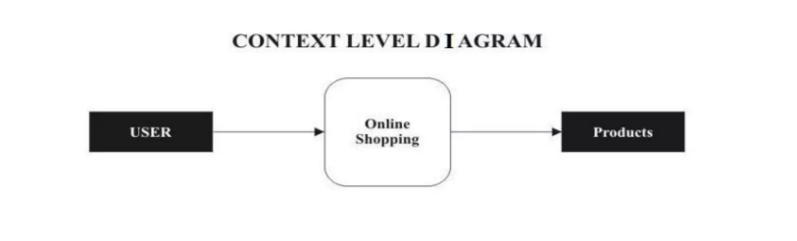

**Fig 3.1**

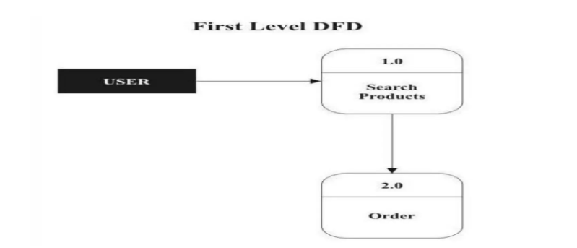

**Fig 3.2**

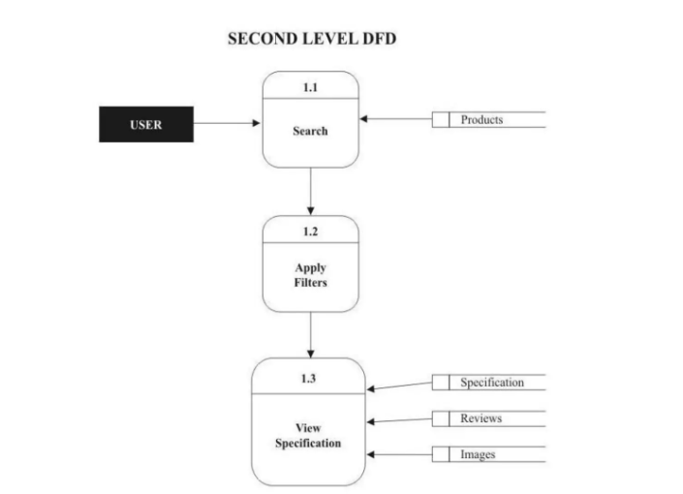

**Fig 3.3**

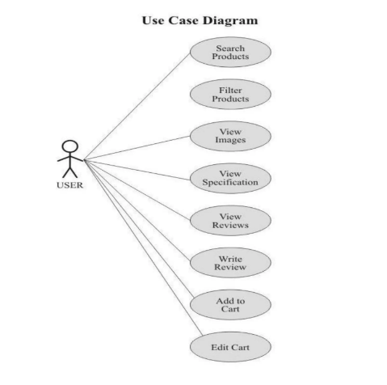

**Fig 3.4**

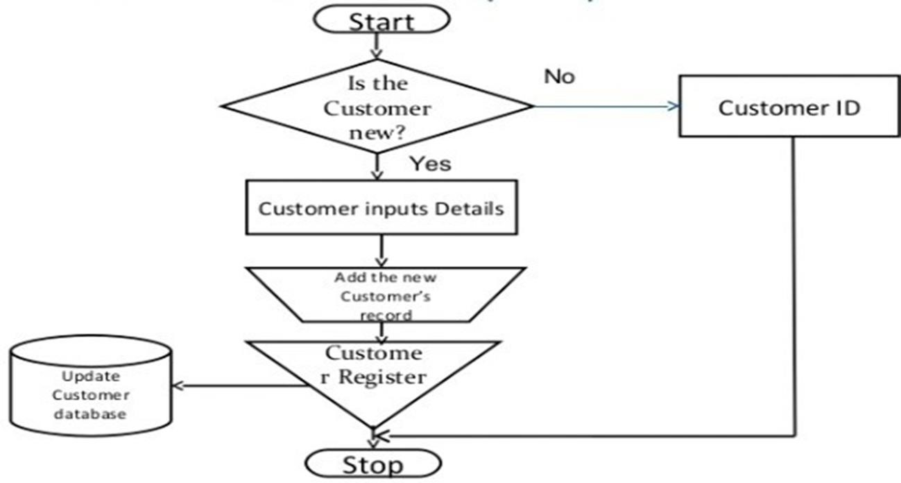

**Fig 3.5**

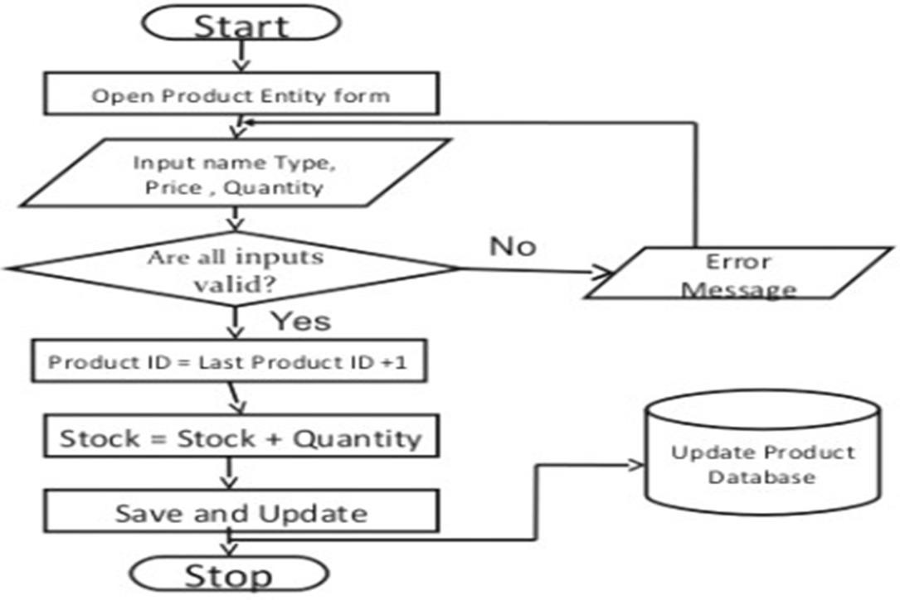

**Fig 3.6**

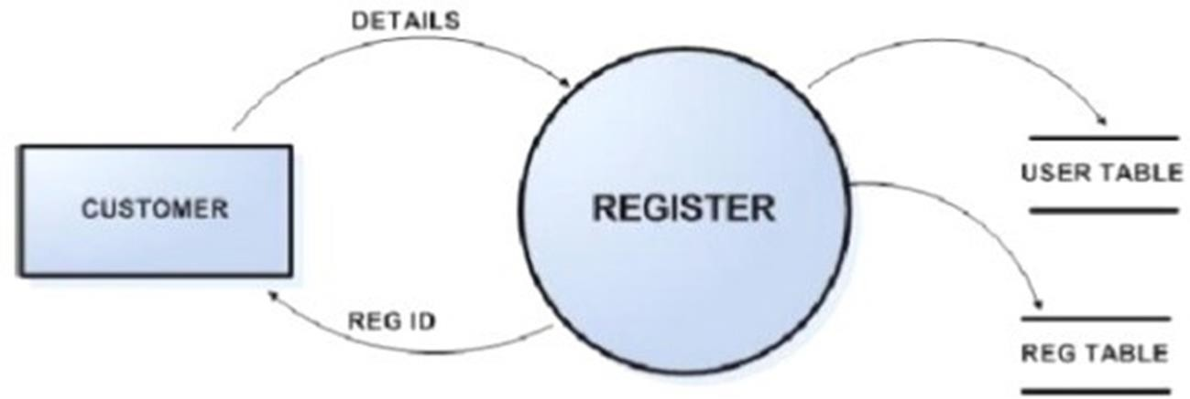

**Fig 3.7**

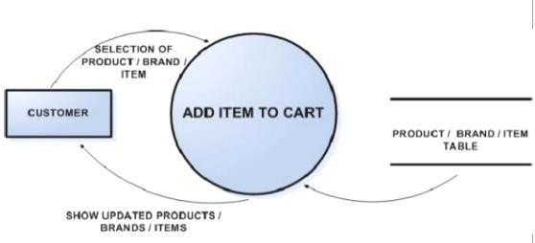

**Fig 3.8**



**Fig 3.9**

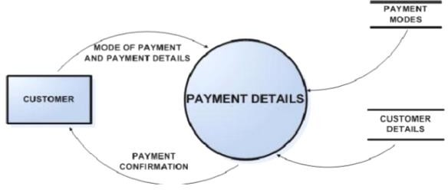

**Fig 3.10**

1. **SOFTWARE REQUIREMENT SPECIFICATION**
   1. Purpose -E-Commerce application is a web Application hosted on a domain which is used to sell and purchase products online in real-time.
   2. Document Conventions-The Documents subsequently explains the needs and traits of the project produced, with sufficient explanation. The important data has expressed in proper fonts and using techniques.
   3. Intended Audience and Reading Suggestions-The application developed is intended to be used by all the people globally who are interested in online purchase and e commerce business.

* **SOFTWARE REQUIREMEN**
* **Operating System : Linux, Ubuntu, Mac, Windows XP, 7, 8, 8.1, 10**
* **Frontend : HTML,CSS, Bootstrap, JavaScript**
* **Backend : node.js, MySQl**
* **Local host : XAMPP/WAMP/LAMP/MAMP**
* **HARDWARE REQUIREMENT**
* **Processor : Pentium IV or Above**
* **RAM : 2GB or above**
* **Hard Disk : 50GB or above**
* **Input Devices : Keyboard, Mouse**

# 

1. **RELATED WORK**
2. We Store the products on the database and the show those products on the User Interface And there we can add products to cart, Empty Cart ,Sign-In ,User Sign-Up ,User Checkout ,Check Ordered Product ,Log-Out ,Login.
3. We work with various approaches of web Development and client-server programming and made a successful E commerce website which is secure and Authenticated.
4. We used agile Approach in development as we make a feature and test it on the point to create a well working End Product.

# CODE & WEBSITE VIEW

## 

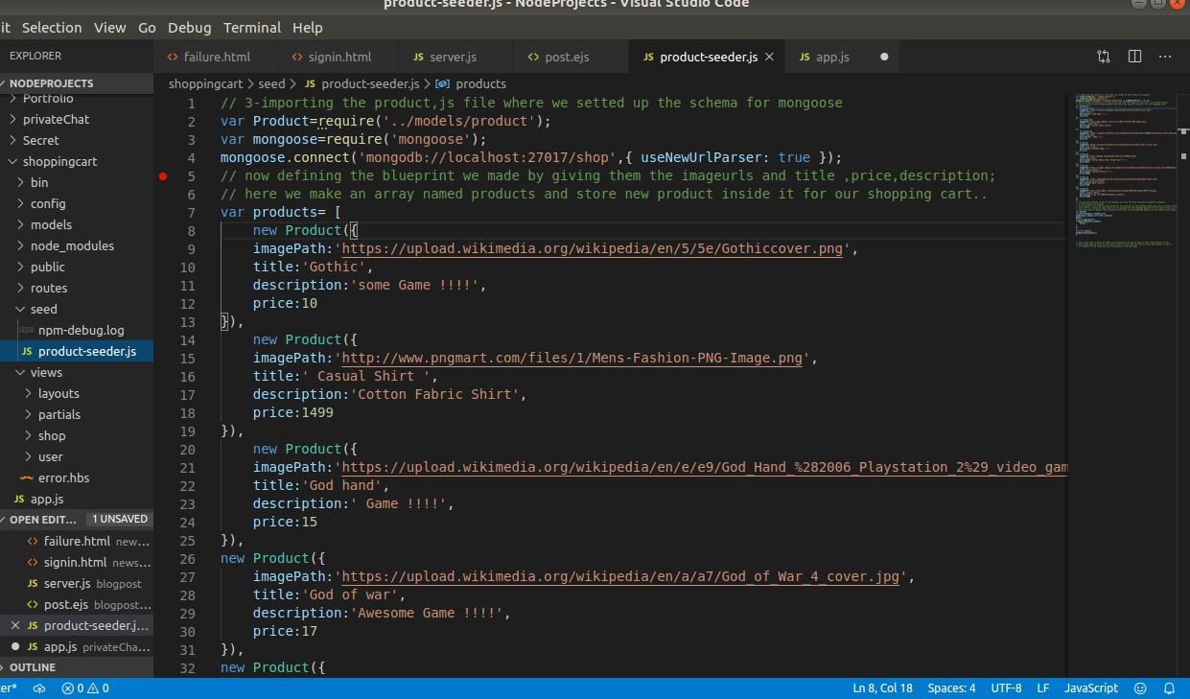

**Fig 6.1**

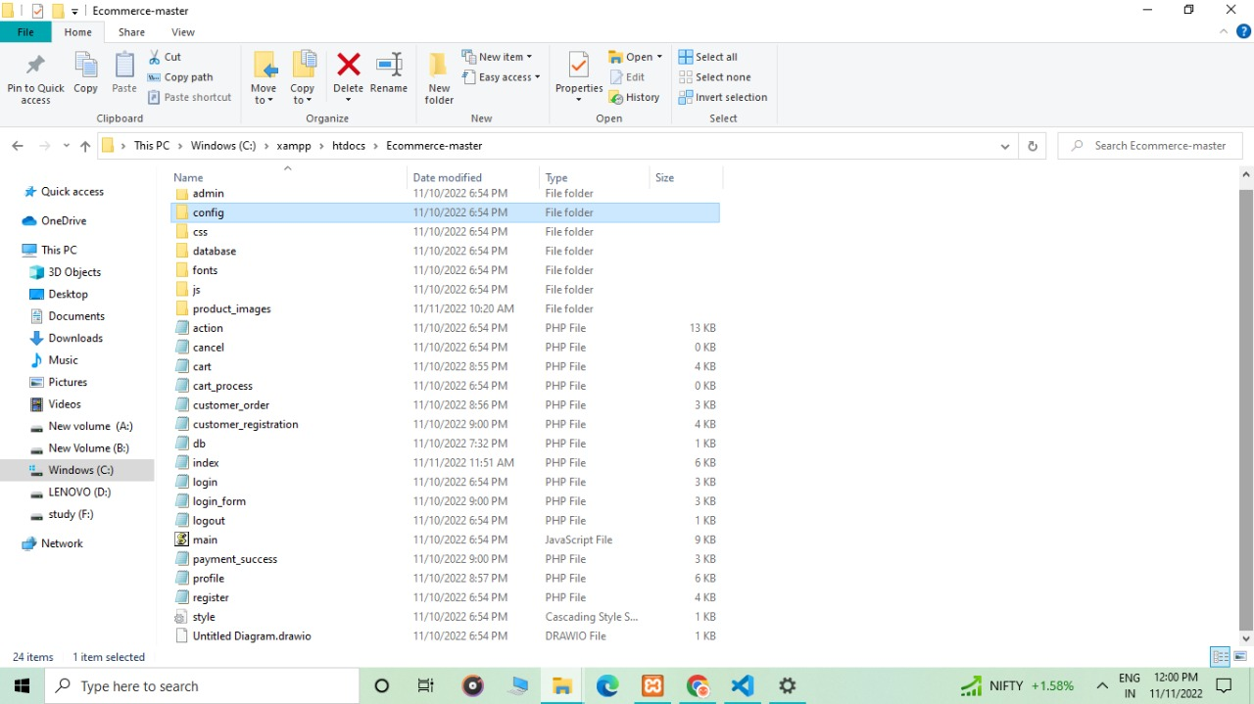

**Fig 6.2**

## 

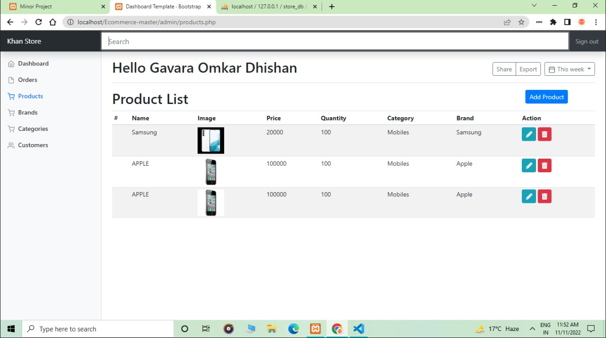

**Fig 6.3**

## 

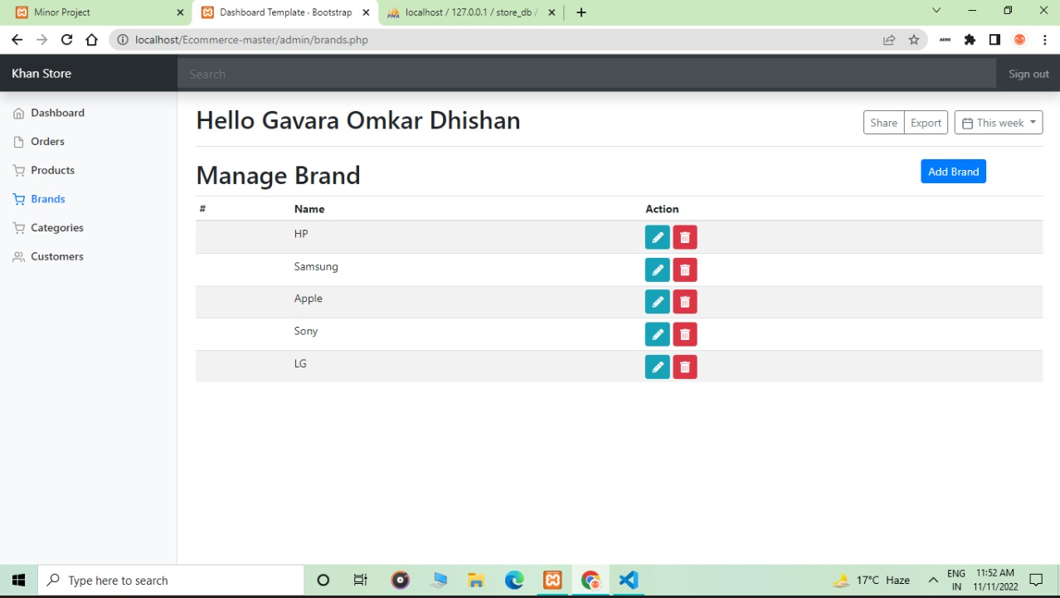

**Fig 6.4**

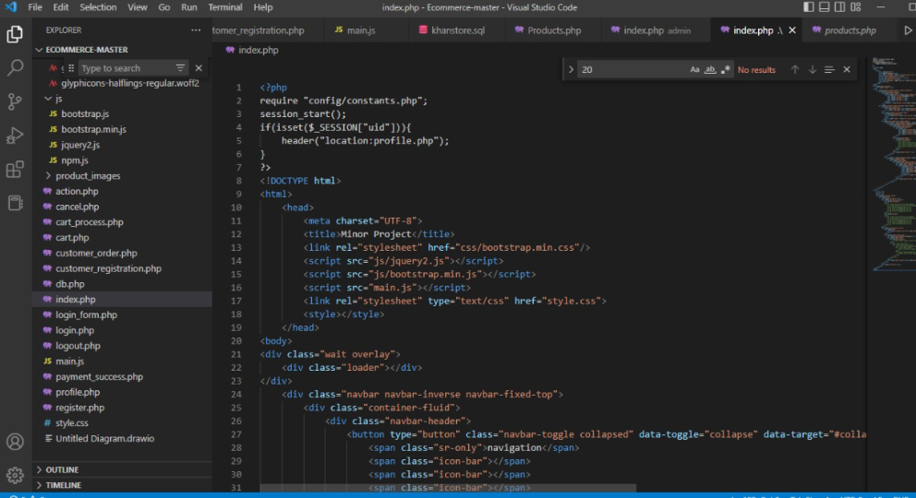

**Fig 6.5**

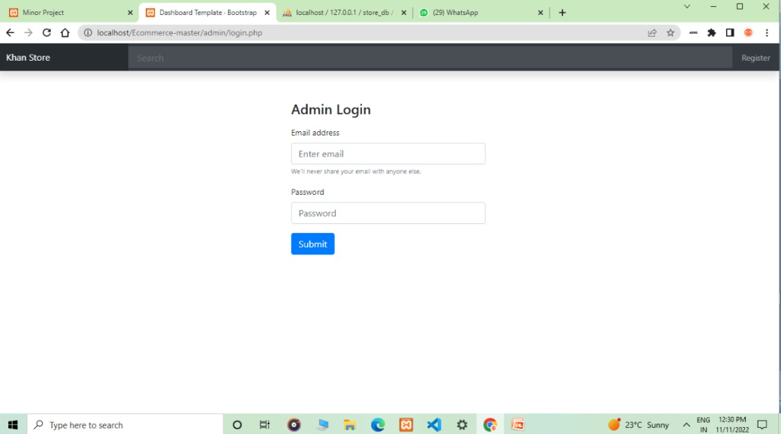

**Fig 6.6**

### 

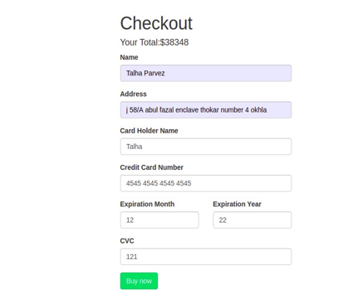

**Fig 6.7**

### 

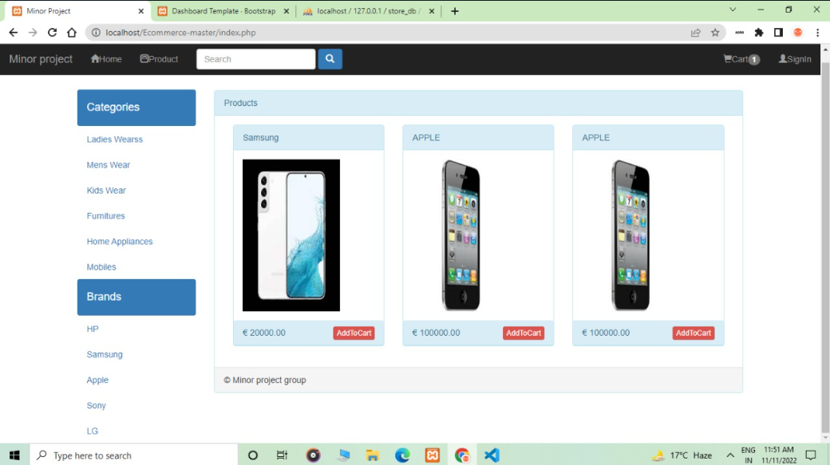

**Fig 6.8**

### 

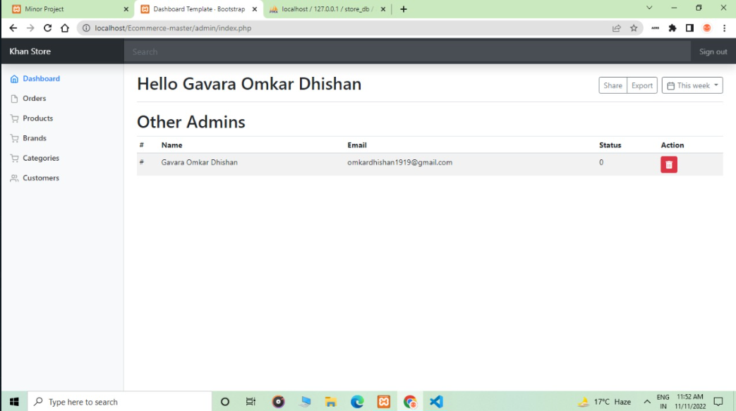

**Fig 6.9**

# RESULT

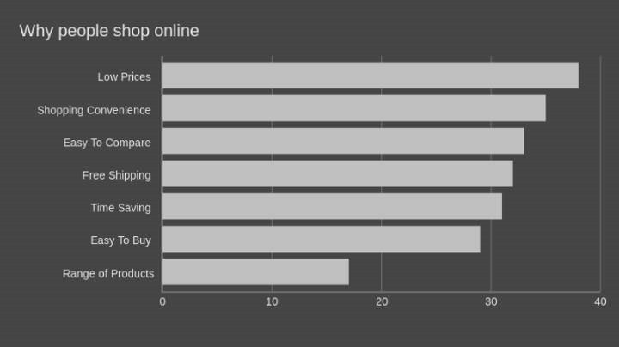

**Fig 7.1**

1. **FUTURE SCOPE**
2. It is executed by technologies of the World of Web Development .
3. It’s a E -Commerce Application which is easy to use.
4. It’s a Application for Real Time Purchase of Products Online With payment feature.
5. Moreover it is User-Friendly.
6. It is very Cost-Effective, Faster, And Reliable, and towards the idea of Online Marketing and E Commerce Buissness.
7. This Application can be used for personal Buissness ,to sell personal product or for a large scale E commerce buissness.

# CONCLUSION

1. To know the future Scope in India itself i went through several articles and came to this conclusion from those articles To understand this scenario, we can divide E-commerce into three broad categories which include physical services, physical goods and virtual goods.
2. Another category that is gradually making its mark is the local commerce (couponing, yellow pages, classifieds etc.) which offers significant overlaps with E-commerce.
3. The 1st category of physical services is definitely the major contributor which includes travel ticketing, jobs, matrimonial and event management websites with travel sites accounting for 75% of all E-commerce industries! It provides attractive deals too.
4. The 2nd category of physical goods is the one currently gaining considerable attention, thanks to the hype created by new startups/stores being launched daily.

# LIMITATIONS

1. The purpose of any e-commerce website is to help customers narrow down their broad ideas and enable them to finalize the products they want to purchase.
2. For example, suppose a customer is interested in purchasing a mobile. His or her search for a mobile should list mobile brands, operating systems on mobiles, screen size of mobiles, and all other features as facets.
3. As the customer selects more and more features or options from the facets provided, the search narrows down to a small list of mobiles that suit his or her choice. If the list is small enough and the customer likes one of the mobiles listed, he or she will make the purchase
4. These facets were different for mobiles that we discussed earlier. Similarly, each category will have different facets and it needs to be designed properly so that customers can narrow down to their preferred products, irrespective of the category they are looking into.

# REFERENCES

##### Research Paper on the title “FUTURE OF E-COMMERCE IN INDIA” by “Nisha Chanana”, Research Scholar, University School of Management, Kurukshetra University, Kurukshetra, 2014.

##### Apte N.K. - E-commerce Shopping Online and Adoption of Safety Measures.

##### Software Engineering Book by Aggarwal K.K., Singh Yogesh, K.K. Aggarwal and Yogesh Singh.

##### Elizabeth Goldsmith and Sue L.T. McGregor(2000); E-commerce: consumer.